Project Design Phase-II Technology Stack (Architecture & Stack)

|  |  |
| --- | --- |
| Date | 09 November 2022 |
| Team ID | PNT2022TMID50435 |
| Project Name | Project - Smart Fashion Recommender Application |
| Maximum Marks | 4 Marks |

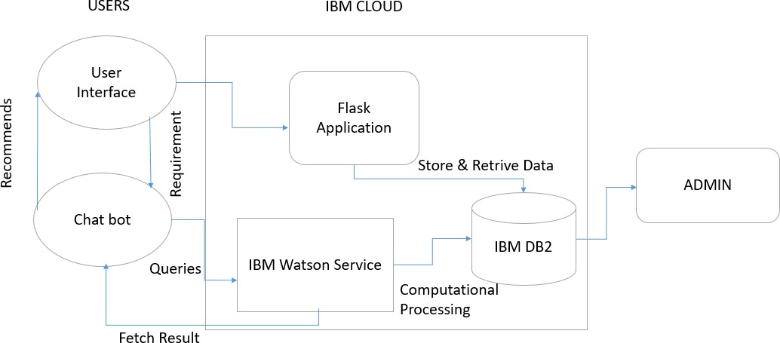

Table-1 : Components & Technologies:

|  |  |  |  |
| --- | --- | --- | --- |
| **S.No** | **Component** | **Description** | **Technology** |
| 1. | User Interface | How the user interacts with app  e.g. Mobile App, Chatbot etc. | HTML, CSS, bootstrap, JavaScript |
| 2. | Requests | How web app communicates with server | Python/JavaScript |
| 3. | Database | To store and retrieve User information | IBM DB2, SQL etc |
| 4. | ChatBot | Address User queries and recommend products. | IBM Watson Assistant |
| 5. | File Storage | File storage requirements | IBM Block Storage or Other Storage Service or Local Filesystem |
| 6. | Infrastructure (Server / Cloud) | Application Deployment on Local System / Cloud Local Server Configuration:  Cloud Server Configuration : | Local, Cloud Foundry, Kubernetes |

Table-2: Application Characteristics:

|  |  |  |  |
| --- | --- | --- | --- |
| **S.No** | **Characteristics** | **Description** | **Technology** |
| 1. | Open-Source Frameworks | Used Web Technologies to build the UI | HTML, CSS, bootstrap, Python, Flask |
| 2. | Security Implementations | User Authentication Through Email Services | Sengrid |
| 3. | Scalable Architecture | Run the application in Local and Cloud system | Docker and Kubernetes |
| 4. | Availability | Justify the availability of application. | Cloud, Docker |
| 5. | Performance | Design consideration for the performance of the application. | Elastic Instance |